Q1.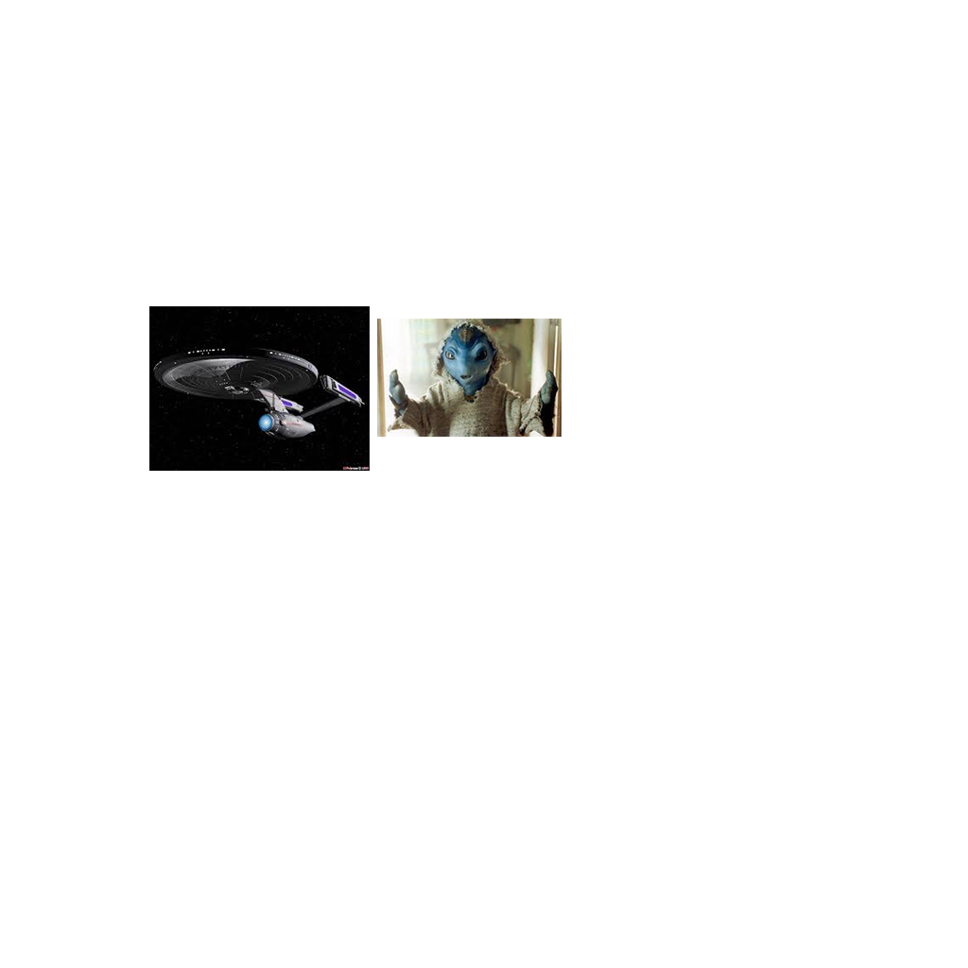

Ans - Nostromo

Q2. I am a cloud.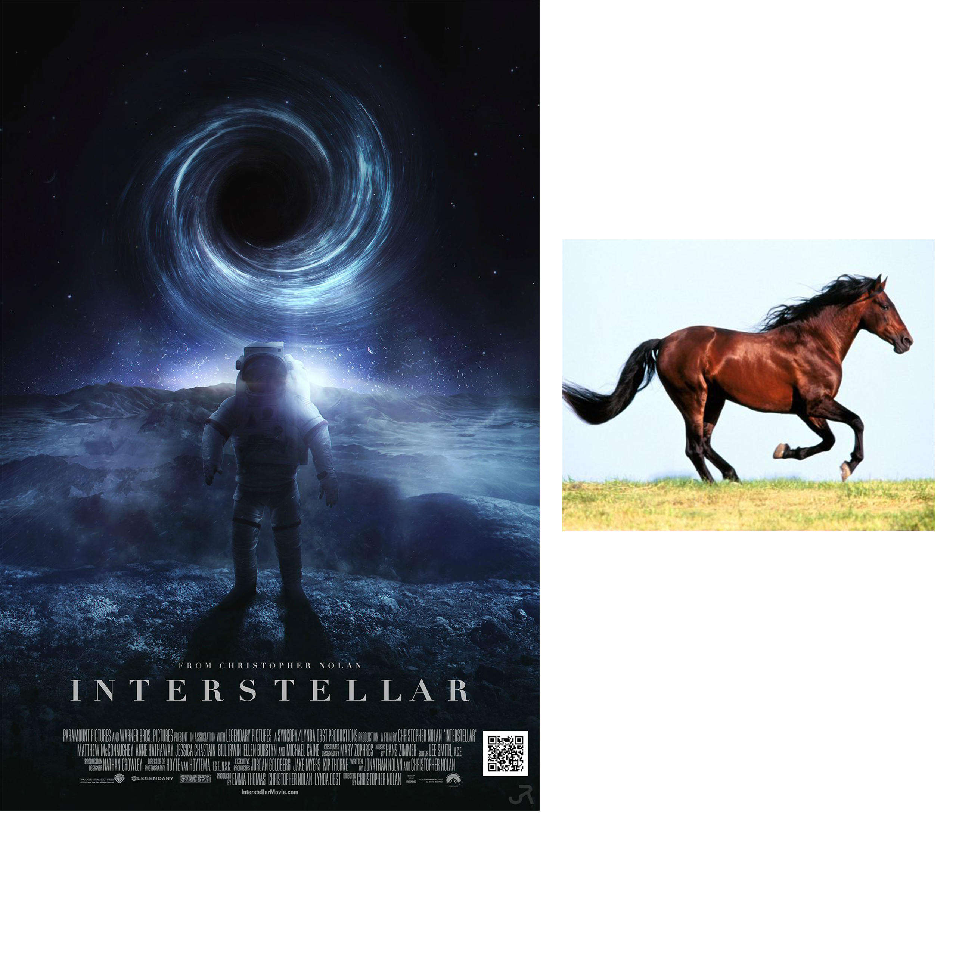

Ans - Hersehead Nebula

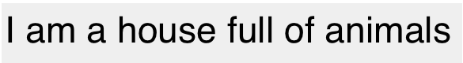

Q3.

Ans- Mark twain national forest

Q4. Identify my name?

Ans - this is 40

Q5. Pedri e figli, Caro michele, ?

What come next.

Ans-il Marchese del grillo

Level - 4

Q6.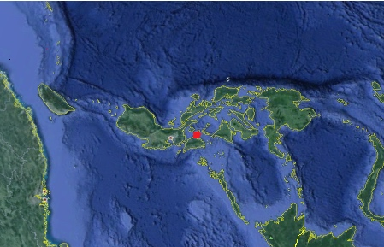 Name the place?

Ans - Philippines